**Pet Selling Management System**

**#Short Description:**

**Here the system make easy the pet selling and buying by owner and customer. There are 3 classes .The pet class hold all the info of a pet and some methods to get the attributes also includes from which owner the pet belongs. Customer class also holds the info of a customer. And finally the PetsellingManagementSystem that intregates the whole system.**

**#Class_Diagram:**

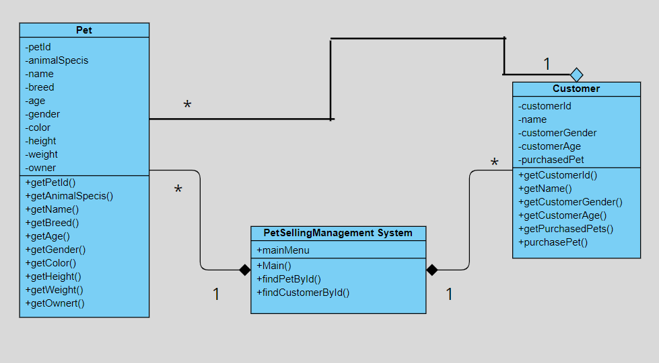

**#Input_Ouput:**

**Here all input are taken in runtime and print the output also in runtime via command line argument.**

**For example:**

**When we run the application first we see a direction “Type ‘0’ to get the main Menu”**

**Then after typing ‘0’ we find the main menu like**

**Type '0' to Get the main MENU: 0**

**Options :**

**1. Add PetInfo**

**2. Show List of Pets**

**3. Add CustomerInfo**

**4. Show List of Customers**

**5. Selling a Pet to a Customer**

**6. Show the list of pets Purchased by a Customer**

**7. All are Done ....Exit.........**

**Press the number that you want to do:**

**Then we can press any number from 1 to 7 to perform the above action**

**Like we can add a pet to the inventory by press/type ‘1’ and type the info about a pet. For example:**

**Press the number that you want to do: 1**

**Enter pet's ID: 101**

**Enter animalSpecis: Cat**

**Enter pet's name: Tom**

**Enter pet's breed: Persian**

**Enter pet's Gender: Male**

**Enter pet's Color: Black**

**Enter pet's Height: .56**

**Enter pet's Weight: 2**

**Enter pet's age: 1**

**Enter pet owner's name: Akram**

**Pet with petId 101 is added successfully.**

**Type '0' to Get the main MENU:**

**Now we can see the inventory info from the main menu by press ‘2’.**

**For example:**

**Type '0' to Get the main MENU: 0**

**Options :**

**1. Add PetInfo**

**2. Show List of Pets**

**3. Add CustomerInfo**

**4. Show List of Customers**

**5. Selling a Pet to a Customer**

**6. Show the list of pets Purchased by a Customer**

**7. All are Done ....Exit.........**

**Press the number that you want to do: 2**

**List of Pets:**

**PetId: 101, AnimalSpecis: Cat, Name: Tom, Breed: Persian, Age: 1, Gender: Male, Color: Black, Height: 0.56, Weight: 2.0, Owner: Akram**

**We can add more and more pet in the inventory.**

**No two pet with same id can added . show error messege.**

**Same thing happen to the customer by pressing ‘3’ and show the info of customer by pressing ‘4’.**

**For example:**

**Type '0' to Get the main MENU: 0**

**Options :**

**1. Add PetInfo**

**2. Show List of Pets**

**3. Add CustomerInfo**

**4. Show List of Customers**

**5. Selling a Pet to a Customer**

**6. Show the list of pets Purchased by a Customer**

**7. All are Done ....Exit.........**

**Press the number that you want to do: 3**

**Enter customer's ID: C101**

**Enter customer's name: Hamid**

**Enter customer's Gender: Male**

**Enter customer's Age: 23**

**Customer with CustomerId C101 is added.**

**Type '0' to Get the main MENU:**

**Show the customer info:**

**Press the number that you want to do: 4**

**List of Customers:**

**CustomerId: C101, Customer Name: Hamid, Customer Gender: Male, Customer Age: 23**

**Type '0' to Get the main MENU:**

**We can add multiple customers here…all here are in runtime until I press 7 to exit.**

**Then come to the sell option.**

**We can sell a pet to a customer by providing the id number by pressing ‘5’ from main menu. For example:**

**Press the number that you want to do: 5**

**Enter customer's ID: C101**

**Enter pet's Id to sell: 101**

**Pet with pet id 101 sold to Hamid.**

**Now in inventory we can’t find the pet with petid 101 cause it has been sold.**

**For example:**

**Pet with pet id 101 sold to Hamid.**

**Type '0' to Get the main MENU: 0**

**Options :**

**1. Add PetInfo**

**2. Show List of Pets**

**3. Add CustomerInfo**

**4. Show List of Customers**

**5. Selling a Pet to a Customer**

**6. Show the list of pets Purchased by a Customer**

**7. All are Done ....Exit.........**

**Press the number that you want to do: 2**

**List of Pets: No Pet found!!!!!!**

**In selling operation if the customer id is not match then or pet id is not match then show a messege that the item is not in inventory or customer not found etc. All exception are handled.**

**Then we can see the Purchased info of a Customer by providing customer id,**

**For example:**

**Press the number that you want to do: 6**

**Enter the CustomerId: C101**

**HamidPerchased :[PetId: 101, AnimalSpecis: Cat, Name: Tom, Breed: Persian, Age: 1, Gender: Male, Color: Black, Height: 0.56, Weight: 2.0, Owner: Akram]**

**Type '0' to Get the main MENU:**

**One customer can Purchased multiple number of pet.**

**Pressing ‘7’ the program will terminate.**

**Here the option are working like an interface.**

**If any data type error occur then an exception throughs and a messege will be shown and terminate the program.**